Name: Petar Filkov
E-mail: pifilkov@yahoo.com
Institution: University of Architecture, Civil Engineering and Geodesy (UACEG) – Sofia, Bulgaria
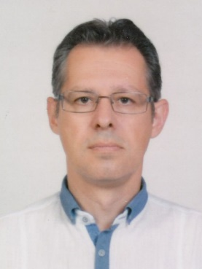 | Petar Filkov, PhD, Associated Professor at UACEG (Faculty of Hydraulic Engineering), was born in 1971 in Sofia, Bulgaria. He graduated in UACEG as MSc in Civil Engineering on Irrigation and Drainage Engineering in 1995. Obtained PhD degree in 2006 at UACEG, habilitated in 2014. Deputy Dean for Research and International Activities of the Faculty of Hydraulic Engineering since March 2016. He has an expertise in Irrigation and Drainage Engineering, especially in the field of rehabilitation, reconstruction and modernization of irrigation systems. He has research experience in the field of water distribution methods for irrigation, pumping stations for irrigation, and use of irrigation equipment. He participated in several projects related to water resources planning. As a member of Faculty of Hydraulic Engineering he took part in development of curriculum for BSc course of Water Engineering, as well as in regular updates of curriculum for MSc course of Irrigation and Drainage Engineering.
References (max. 5 relevant references)
1. A short-term consultant of the World Bank in the field of irrigation and water resources management for the project “Technical Assistance: Municipal Infrastructure Development Plans” (2017).
2. A short-term consultant of the World Bank in the field of irrigation and drainage engineering for the project „Draft Common Strategy for Management and Development of Hydro-melioration and Protection Against Harmful Effects of Water” (2014-2015).
3. Filkov, P., Nachev, G., Mihaylova, G., Tonchev, G., 2013. “A New Life for the Old Pumping Stations?”. “Ovidius” University Annals, Series: Civil Engineering, Constantza, p. 133 – 140.
4. Filkov, P., Meranzova. R., 2011. “Pump Selection for Extending Drip Irrigation Systems”. “Ovidius” University Annals, Series: Civil Engineering, Constantza, p. 13-20.
5. Filkov, P., Gerinski, J., 2010. "Design Discharge of Irrigation Pumping Stations Under Reconstruction". "Ovidius" University Annals, Series: Civil Engineering, Constantza, p. 359-366.

This project has been funded with support from the European Commission. This publication reflects the views only of the author, and the Commission cannot be held responsible for any use which may be made of the information contained therein.

